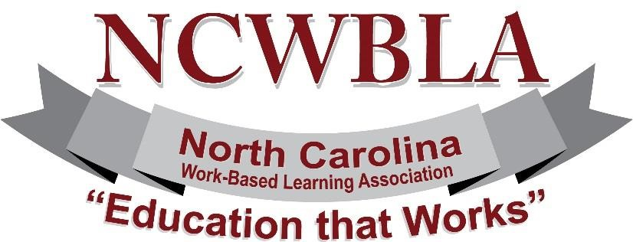

NCWBLA MEMBERSHIP APPLICATION

The NCWBLA (formally NCCEA) membership year is from January 1 through December 31.

You can become a member by completing the NCWBLA Membership Application and paying annual dues of
$25 for an individual or $40 for an organizational membership (2 members). Individual dues are not transferrable nor are any dues pro-rated.

For those attending the Annual Conference, dues are included as a part of the registration fee.

Please complete (Print or Type) and mail the form to the address below with your payment (do not send cash through the mail).

New Member |  | Renewal
Individual Membership $25.00 |  | Organizational Membership $40.00
Last Name | First Name |  |  | Middle Initial
Job Title
Company/College Name

Work Phone | Cell Phone |  |  | Fax
Street Address
City |  |  | State | Zip
E-mail Address
Home Page URL

PLEASE RETURN TO:
Sherry Irsik, NCWBLA Treasurer
Lenoir Community College
PO Box 188
Kinston, NC 28502

